

**SYSTEM OVERVIEW**

*Sample Text here sample text here sample text here sample text here sample text here sample text here sample text here sample text here sample text here sample text here sample text here sample text here sample text here sample text here sample text here sample text here sample text here sample text here sample text here sample text here sample text here sample text here sample text here sample text here sample text here sample text here sample text here sample text here sample text here sample text here sample text here sample text here sample text here sample text here sample text here sample text here sample text here sample text here sample text here sample text here sample text here.*

**GENERAL INFORMATION OF SYSTEM**

*Sample Text here sample text here sample text here sample text here sample text here sample text here sample text here sample text here sample text here sample text here sample text here sample text here sample text here sample text here sample text here sample text here sample text here sample text here sample text here sample text here sample text here sample text here sample text here sample text here sample text here sample text here sample text here sample text here sample text here sample text here sample text here sample text here sample text here sample text here sample text here sample text here sample text here sample text here sample text here sample text here sample text here.*

**SYSTEM PREFACE**

*Sample Text here sample text here sample text here sample text here sample text here sample text here sample text here sample text here sample text here sample text here sample text here sample text here sample text here sample text here sample text here sample text here sample text here sample text here sample text here sample text here sample text here sample text here sample text here sample text here sample text here sample text here sample text here sample text here sample text here sample text here sample text here sample text here sample text here sample text here sample text here sample text here sample text here sample text here sample text here sample text here sample text here.*

**User Manual – General Users**

**CEU Purchasing System**

General Users Dashboard

*Figure 1.0 – Dashboard*

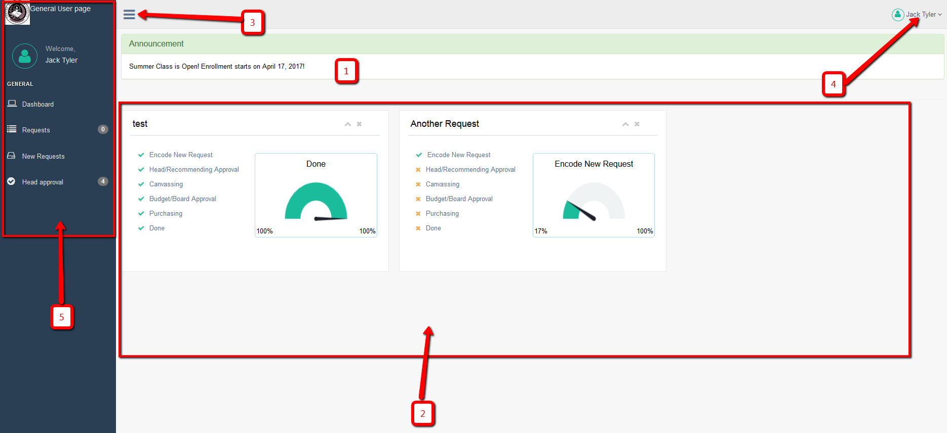

1. Announcement area.
2. It shows all your current request showing its level of progress.
3. Hide/Show side bar menu
4. Top navigation
   1. Settings
   2. Help
   3. Logout
5. Side bar menu

**Request**

Note: There you can see the number at the right side of the menu. That means that you have a number of tasks for that menu and you need to take action. Also note the every list or table of that page where you can see the green row, which means that you need to take action on that row.

* Users can see his/her request only on this page

**New Request**

* This menu is the step where you can request.

**Head Approval**

* This menu or page will appear only if you have assigned by the admin as a head of the department. There you can see the newly requested by your staff or even other department staff if it is assigned to you as a recommending approval.
* The buttons under “Action” button will be different depends on the current status of the request.
* Click the “View Items” button to view the items that is assigned to you. See figure 3.1. You can also see the items that is assigned to the other head (see *Assigned To* column). You can approve and deny only the item assigned to you. When you deny, it will notify the requisitioner. Once the requisitioner will response, it will appear the response to the *Requisitioner Note* column. All the items should be approved by all the recommending officer before it will be forwarded to the admin.